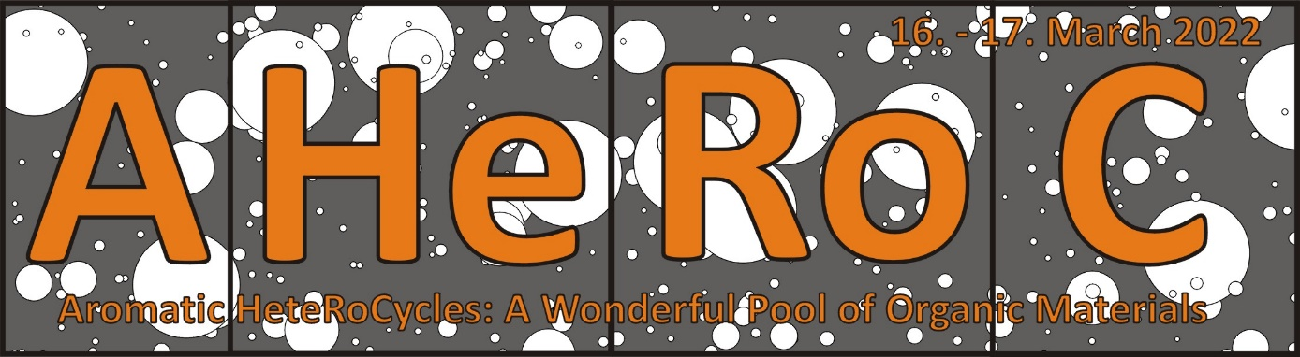
Name:
Surname:
Affiliation:
Country:
E-mail:
Homepage:
Type of Contribution:
Invited Talk (40+10 min)
Contributed Talk (15+5 min)
No Contribution (Listener)
Send the completed form and abstract to Patrik.Parik@upce.cz. Invited speakers are kindly requested to send a photograph (as a separate file) to be presented at the webpage.

Title of Your Talk (Calibri, 16 pt, Bold, Capitalized)
Presenting Author,ª Author B,^{b} Author C^{c} (Calibri, 14 pt)
ª Institute of Organic Chemistry and Technology, Faculty of Chemical Technology, University of Pardubice, Studentská 573, Pardubice, 53210, Czech Republic.
http://bures.upce.cz; filip.bures@upce.cz. (Calibri, 11 pt)
^{b} Affiliation B.
^{c} Affiliation C.
Fill in a short abstract of your talk and include references [1]. Use Calibri, 11 pt and 1.15 line spacing. The abstract should not exceed one A4 page (two A4 pages for invited talks). Use ACS style for all references, an example is given below. ACS Document 1996 template should be used for drawings (ChemDraw or similar), feel free to use colors. Please do not alter formatting of the template, rather fill in your data. Rename the abstract as “surname.docx” and send it along with the above registration form to Patrik.Parik@upce.cz. The deadline is 18. February 2022. All abstracts will be posted on the conference webpage along with the title of your talk and will be included in the book of abstracts.
Figure 1. Favorite aromatic (hetero)cycle.
Acknowledgement: This work has been supported by….
References:
[1] Klikar, M.; Solanke, P.; Tydlitát, J.; Bureš, F. Alphabet-Inspired Design of (Hetero)Aromatic Push–Pull Chromophores. Chem. Rec. 2016, 16, 1886–1905.

